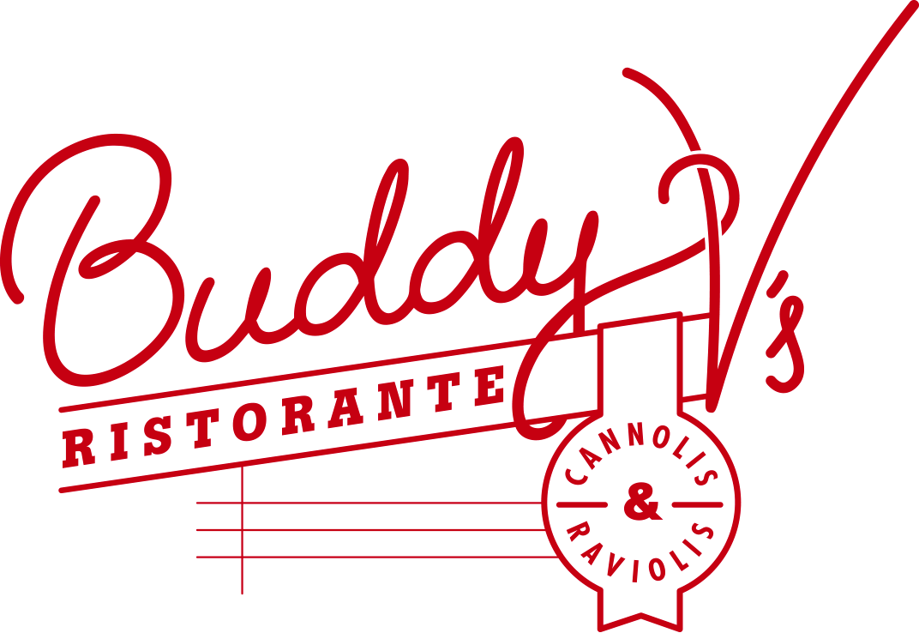

**Christmas Prix Fixe Menu**

**$59 per person**

***APPETIZER***

**Roasted Butternut Squash Soup**

apple-squash compote, spiced pepitas

panna dolce

*$13*

***ENTRÉE***

**Slow Roasted Prime Rib**

whipped parmesan potatoes

roasted brussel sprouts, smoked bacon horseradish crema

*$40*

***DESSERT***

**Gingerbread Trifle**

cranberry, phyllo cup

$14

***Bottle of Prosecco***

***$28***

***Wine Pairing***

***$24 per person***



Pricing does not include tax or gratuity; all bar and beverage will be charged on consumption.

**Christmas Prix Fixe Menu**

**$59 per person**

***APPETIZER***

**Roasted Butternut Squash Soup**

apple-squash compote, spiced pepitas

panna dolce

*$13*

***ENTRÉE***

**Slow Roasted Prime Rib**

whipped parmesan potatoes

roasted brussel sprouts, smoked bacon horseradish crema

*$40*

***DESSERT***

**Gingerbread Trifle**

cranberry, phyllo cup

$14

***Bottle of Prosecco***

***$28***

***Wine Pairing***

***$24 per person***



Pricing does not include tax or gratuity; all bar and beverage will be charged on consumption.